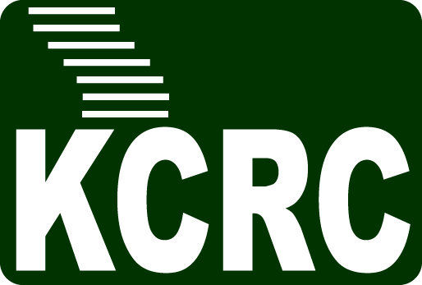 | Kigali Collaborative Research center  KG 7 avenue, Boulevard de l’Umuganda,  Kigali, Rwanda BP 6150  Email: info@kcrc.rw

PROJECT SPONSORSHIP APPLICATION

I / We would like to sponsor a research project at Kigali Collaborative Center:

SPONSOR’S DETAIL

COMPANY/ORGANISATION:………………………………………………………………………………...……

ADDRESS:

…………………………………………………………………………………………………………...………………..…

………………………………………………………………………………………………………...……………………..

POSTCODE : ………………….. CITY: ……………………………

STATE: …………………………………. COUNTRY: …………………………….……...

CONTACT PERSON : …………………………………… TITLE: ………..……………………………

TEL. : ................................................ MOBILE: ……………………………..

EMAIL : ………………………………………………………………………..

SPONSORED PROJECT

Please tick the boxes below that most closely correspond to your research discipline or areas of sponsorship
General (Any research topic)
Information and Communications Technologies (ICT)
Energy Systems
Data Science
Robotics/Artificial Intelligence
Mathematical Sciences
Water, Sanitary, Environment
Transportation Systems
Manufacturing and Production Systems
Social Sciences, Development
Governmental Policy and Regulation
other (please specify) _____________________________________________________

PROJECT DESCRIPTION (optional)

You can provide a brief description of any specific project that you would like to sponsor

Sponsorship Amount : ………………………………………………………………………..

Signature : ………………………………………………………………………..

Note : Please send your official logo and website information for inclusion of sponsor’s name and logo for event advertisement and publicity materials.
Please complete and send the form in PDF format to info@kcrc.rw

